pleasantville ayso Blue sombrero guide :Game Reports

Introduction
In Summer 2017 AYSO nationally adopted the blue sombrero product to act as a registration/team management/ admin portal. As of fall 2017 there are still a number of non-intuitive functions in that portal and a series of how to guides is being produced to help users navigate the noise.
This document focuses on Game Reports

basic Information
Team Volunteers need to be enabled by RC to Post Game reports by doing the following :
Go to Team Central -> Team Directory
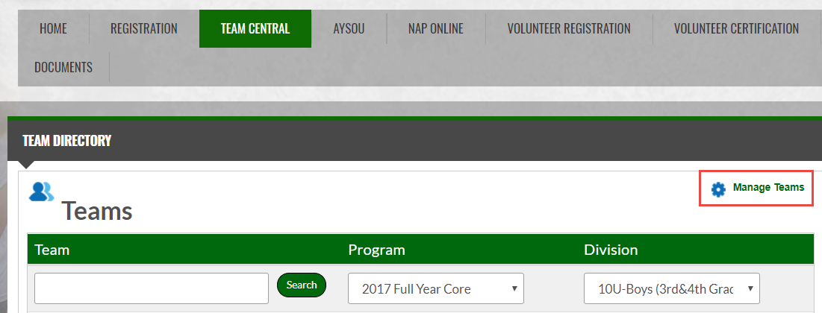
Select "Manage Teams"
Scroll to the bottom of the window that pops up and toggle this setting to Yes :
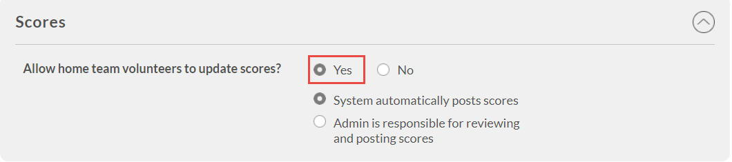
The recommendation is to leave System Automatically Posts Scores as checked.
Make sure to hit update before leaving the screen.
This should update for all divisions

Inputting Scores
For Coaches to Enter scores do the following :
- Navigate to your Team Site
- Select the Calendar view
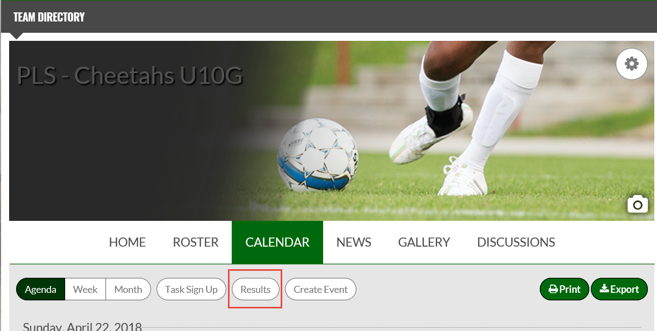
- Now Click on Results – this will bring you to a screen like the following :
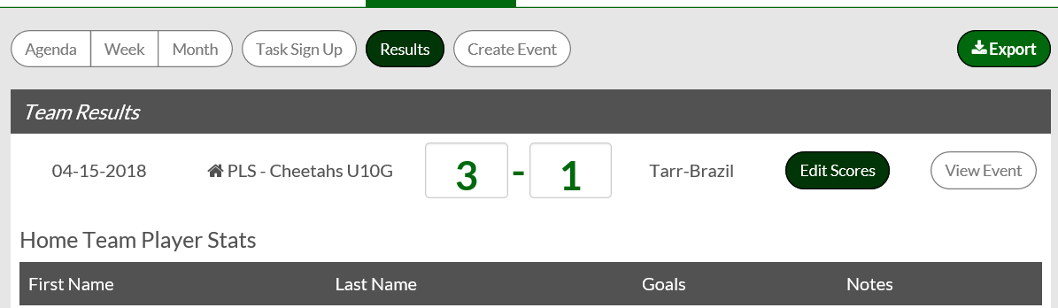
Click Edit Scores & enter the score as well as any details around scorers or player notes then scroll to the bottom and hit :
This will Save and post the score

Referee Notes
Many regions want their referees to be able to amend scores and provide feedback. The easiest way to do this is to do the following :

- Grant your referees "Scores Admin" rights. Common -> roles -> Scores Admin -> Manage Users
You need to find each user individually and add them to the role *
- Now next time they login they will see :

- When They click on Schedules and Select "Scores"
This will give them access to the system to enter scores for each game , By Division

- The Screen is slightly different to the Coaches View in that a "Scores Admin" can see the following:
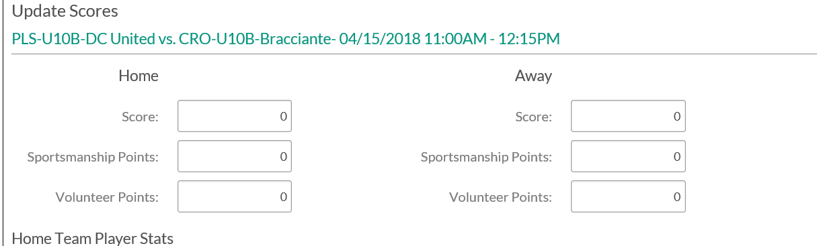
At this point in Time Area 3T does not require the population of the Sportsmanship or Volunteer Points

* It may be easier to create a generic login for Referees and assign the right to the generic login

